From the Desk of
Ruth Gibson Elementary School PTO

The Gibson Elementary Ronda McCormick PTO Scholarship
Awarded by the Gibson Elementary School PTO in honor of Ronda McCormick

PURPOSE: To award one (1) Bullard High School student, a Gibson Alumni, with an academic scholarship in the amount of $500.

HOW TO APPLY: Please complete the attached application as well as provide a one-to-two page, typed (double-spaced) essay, answering the following question in detail:

If you were tasked with mentoring one Gibson Elementary Student (any grade, K-6) and helping guide them/prepare them for their future, what would you focus on and why? What advice would you give this student to prepare them for their high school years? How could you have benefitted from your own advice/guidance when you were young?

DEADLINE: Applications and essays are due to your guidance counselor by Thursday, April 30th and will be reviewed by our Gibson Elementary PTO. A recipient will be chosen and notified by email by Friday, May 15th.

Thank you in advance for your application submission and good luck!

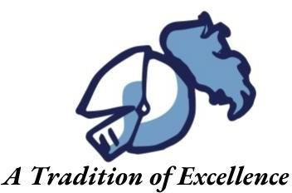

The Ronda McCormick Scholarship Application

Name:

First Mi Last

Street Address:

First Mi Last

Phone: __________________________Email: ________________________________________

-----------------------------------------------------------------------------------------------------------------------------------------

List the number of years and dates you attended Gibson Elementary:

Cumulative GPA: (Your most recent transcript is required, please attach unofficial copy)

College attending in Fall 2024:

School Activities:

Community Service Activities:

Honors/Awards Received:

-----------------------------------------------------------------------------------------------------------------------------------------

Applicant’s Signature: Date:

Parent/Guardian Signature: Date:
The Ronda McCormick Application Checklist

Application: Applicant Signature
Parent Signature
Transcript

Written Essay (1-2 pages typed, double spaced)

***Application and essay must be turned into your guidance counselor by Thursday, April 30th!

