Name____________________________________ Score _____________
Period_________
AP Calculus Summer Assignment

*This assignment is due on the first day of the school year.

*Solve the problems and circle the answers in the answer packet. Make sure that your work is neat and orderly. You must show your work for credit.

*If you can’t fit the work in the space provided, show the work neatly on a lined sheet of paper. The problems must be numbered, in numerical order and clearly separated from each other.

*The skills practiced when solving these problems are some of the requisite skills required to succeed in AP Calculus. Some of the problems have examples which serve as reminders as to how you can solve the problem set. If you struggle to remember how to solve a problem set, you should go online to Khan Academy or YouTube, search for the problem type and watch videos related to the problem.

*I am looking forward to working with you in the 2017-2018 school year! I love teaching this class and I love the privilege of working with motivated math students, like you!

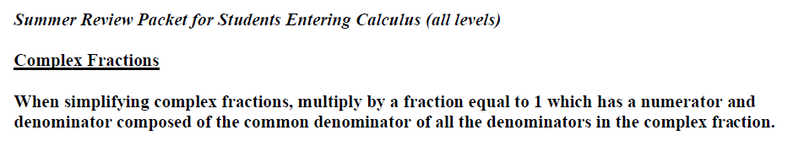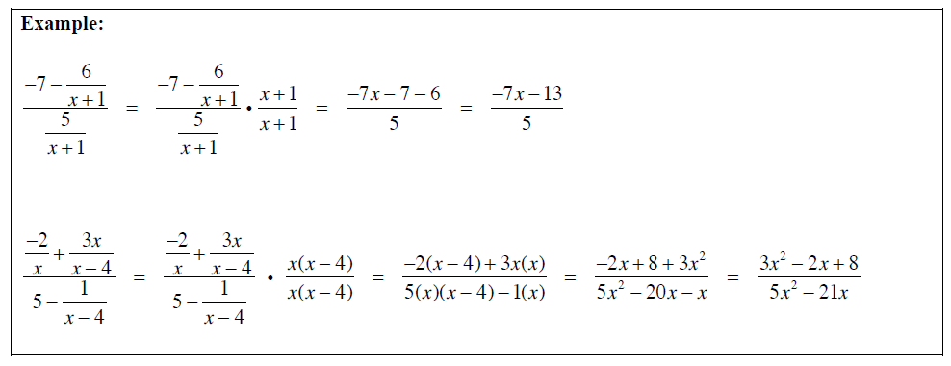
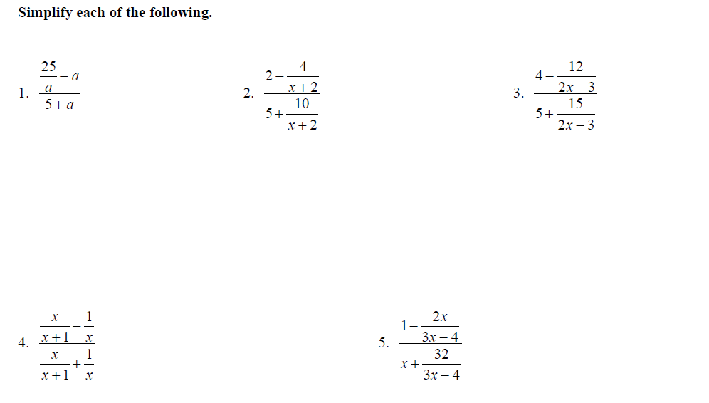
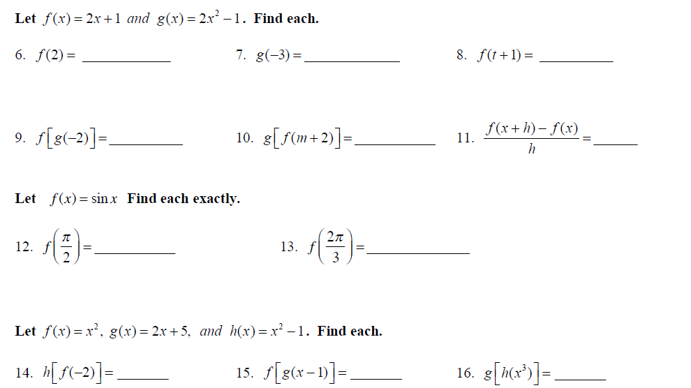

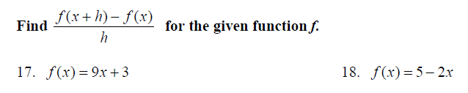

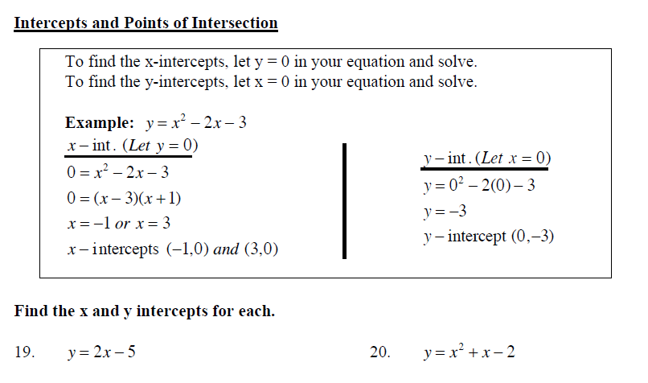

For Problems 25 through 34:
- Graph each function.
- State the domain and range of each function. Write answers in interval notation.
25. $y=x$ 26. $y=(x-2)²$ - 1
Domain: Domain:
Range: Range:

27. $y=(x+1)³$ 28. $y=x(x+2)(x-3)(x-5)$
Domain: Domain:
Range:

29. $y= \sqrt{x-3}$ 30. $y= \frac{1}{x}$
Domain: Domain:
Range: Range:

31. $y= \sqrt{9-x²}$ 32. $y=\sin{x}$
Domain: Domain:
Range: Range:

33. $y=\cos{x}$ 34. $y=\ln{x}$
Domain: Domain:
Range: Range:

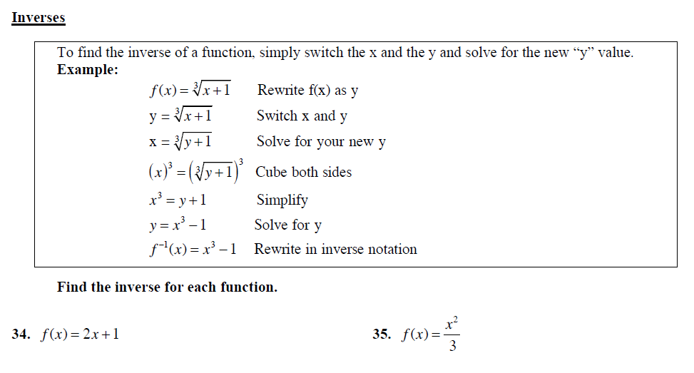

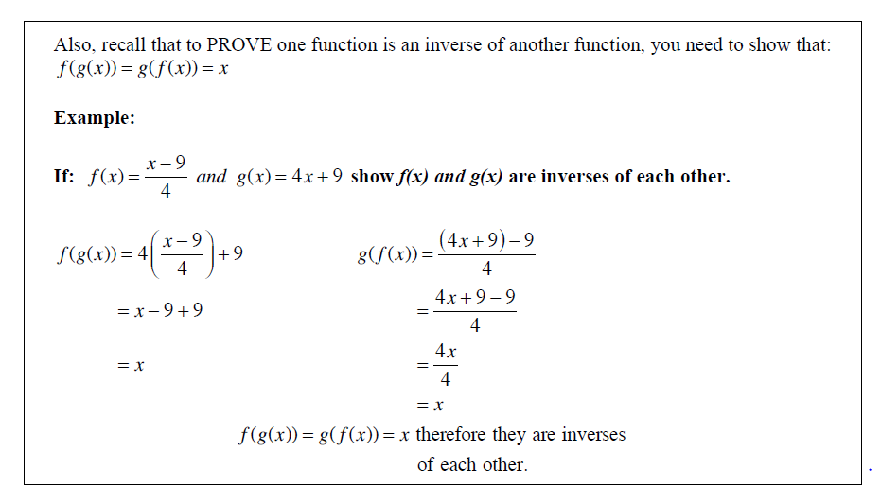
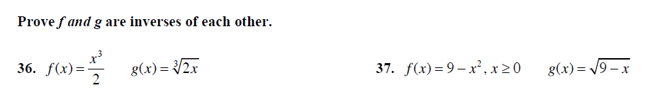

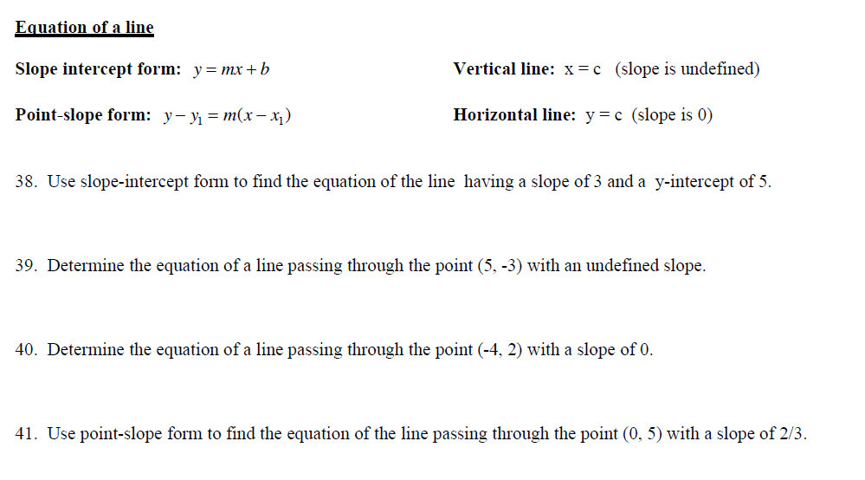
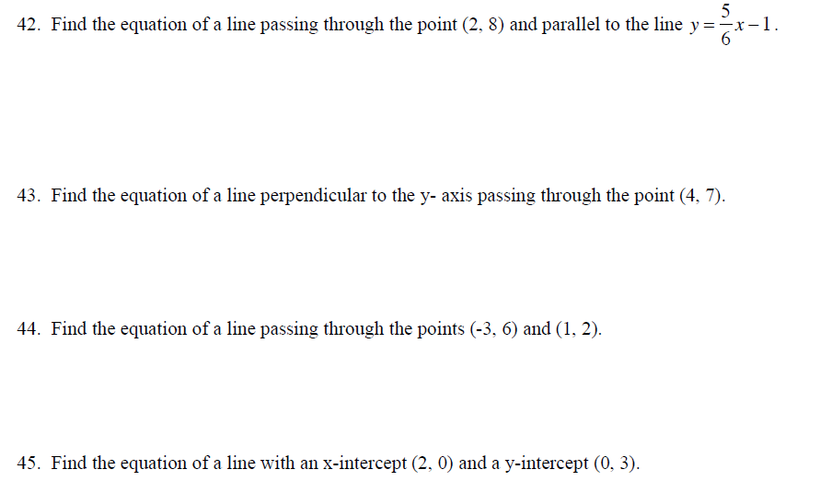

Solve the Unit Circle by:
- Writing the degree measurements on the line marked with the degree symbol.
- Writing the radian measurements on the line without the degree symbol.
- Writing the coordinates inside the parenthesis.
- Stating which trig functions (sin, cos, tan) are positive or negative in each quadrant.
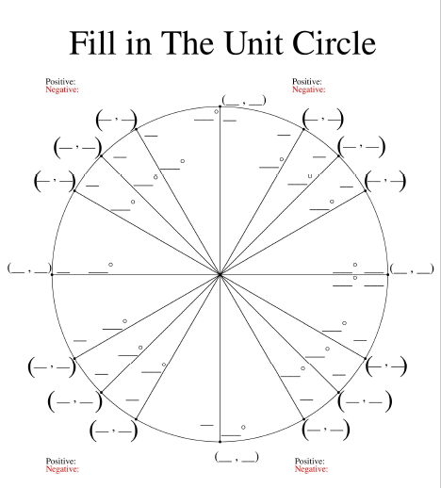
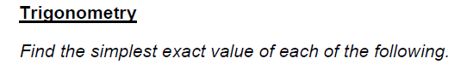
46. sin ($\frac{2ᴨ}{3})$ 47. cos $(\frac{ᴨ}{6})$ 48. tan $(-\frac{ᴨ}{4})$

49. $\sec{(\frac{ᴨ}{2})}$ 50. $\csc{(\frac{2ᴨ}{3})}$ 51. cot $(-\frac{ᴨ}{4})$

52. arcsin (0) 53. arctan (-1) 54. arccos $(\frac{\sqrt{3}}{2})$

55. arccsc (1) 56. arcsec $(2)$ 57. arccot (-1)

For problems 58-63, identify the Pythagorean Identity using cos²x + sin²x = 1.
58. cos²x = ____________ 59. sin²x = _____________

60. tan²x = ____________ 61. sec²x = _____________

62. csc²x = ____________ 63. cot²x = _____________

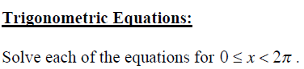
64. 2 cos x = $\sqrt{3}$ 65. sin²x = $\frac{1}{2}$

66. 2 cos²x – cos x – 1 = 0 67. 4 cos²x – 3 = 0

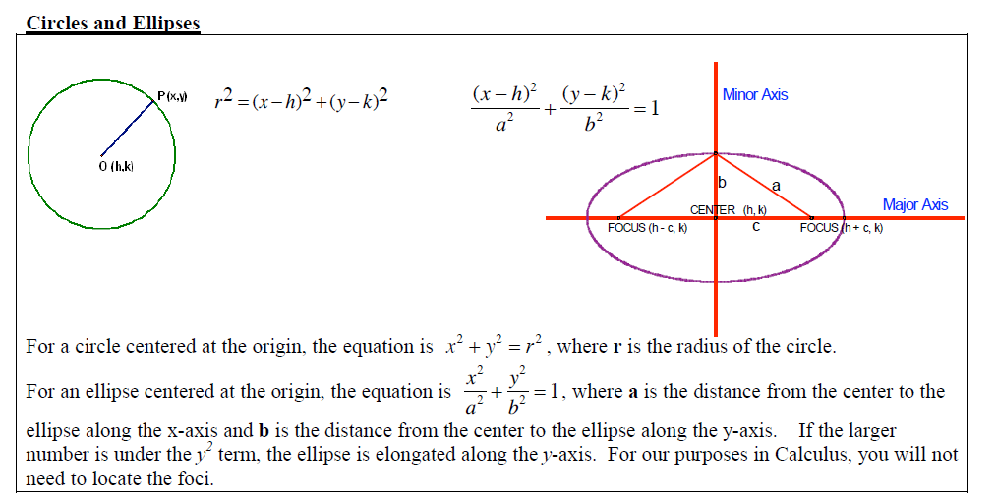
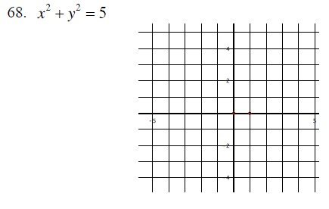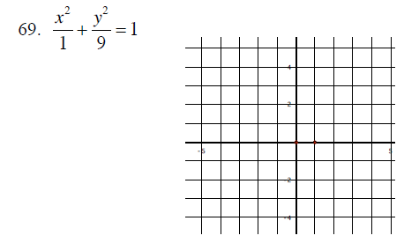
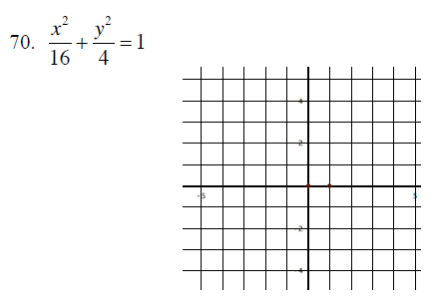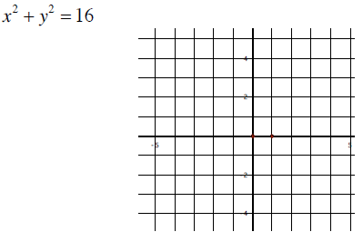

Graph the piece-wise functions. Adjust the dimensions of the graph if necessary.
72. $f\left(x\right)=2x+1, if x≥1$ 73. $f\left(x\right)= -x+2, if x ≤2$
$f\left(x\right)=x^{2}-3, if x<1$ $f\left(x\right)= \sqrt{x-2} , if x>2$
Simplify the following.
74. $\frac{x^{2}+5x+6}{x+2}$ 75. $\frac{6x^{2}+x-12}{3x-4}$

76. $\frac{8x^{2}-6x+1}{4x^{2}+23x-6}$ 77. $\frac{9-x²}{x^{2}-2x-3}$

78. f(x) = $\frac{1}{x²}$ 79. f(x) = $\frac{x²}{x^{2}-4}$ 80. f(x) = $\frac{2+x}{x²(1-x)}$
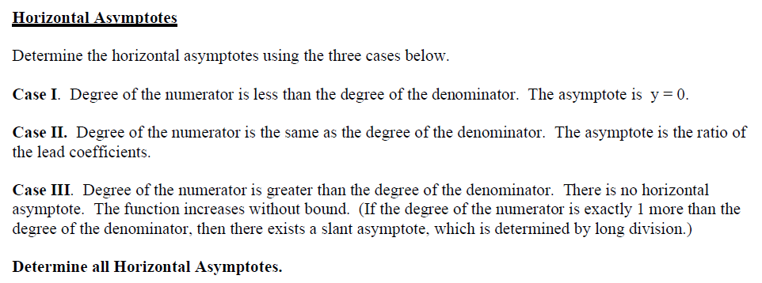

81. $f\left(x\right)= \frac{x^{2}-2x+1}{x^{3}+x-7}$ 82. $f\left(x\right)= \frac{5x^{3}-2x^{3}+8}{4x-3x^{3}+5}$ 83. $f\left(x\right)= \frac{3x⁴}{5x^{2}+7x-16}$

Simplify.

84. x²[4(x – 2)³] + (x - 2)⁴(2x) 85. x[3(3x – 9)²(3)] + (3x – 9)³

86. x[$\frac{1}{2\sqrt{x^{2}+5}}(2x)] + \sqrt{x^{2}+5}$ 87. x[$\frac{1}{2\sqrt{1-x^{2}}}(-2x)] + \sqrt{{1-x}^{2}}$

88. x²[$\frac{1}{2\sqrt{9-x^{2}}}(-2x)]+(2x)\sqrt{9-x^{2}}$ 89. x[$-\frac{1}{2\sqrt{(x^{2}+1)³}}(2x)] + \frac{1}{\sqrt{x^{2}+1}}$

